**5: A television shop employs a single repairman to overhaul its rented television sets, service customers’ sets and do on-the-spot repairs. Overhaul of company owned television sets commences every 40±8 hours and takes 10±1 hours to complete. On-the-spot repairs, such as fuse replacement, tuning and adjustments are done immediately. These arrive every 90±10 minutes and take 15±5 minutes. Customers’ television sets requiring normal service arrive every 5±1 hours and take 120±30 minutes to complete. Normal service of television sets has a higher priority than the overhaul of company owned, rented sets.**

**1. Simulate the operation of the repair department for 50 days.**

**2. Determine the utilization of the repairman and the delays in the service to customers.**

**Code:**

GENERATE 2400,480,,,1 ;Overhaul of a rented set

QUEUE Overhaul ;Queue for service

QUEUE Alljobs ;Collect global statistics

SEIZE Maintenance ;Obtain TV repairman

DEPART Overhaul ;Leave queue for man

DEPART Alljobs ;Collect global statistics

ADVANCE 600,60 ;Complete job 10+/-1 hours

RELEASE Maintenance ;Free repairman

TERMINATE ;Remove one Transaction

*****************************************************************

* On the spot repairs

GENERATE 90,10,,,3 ;On-the-spot repairs

QUEUE Spot ;Queue for spot repairs

QUEUE Alljobs ;Collect global statistics

PREEMPT Maintenance,PR ;Get the TV repairman

DEPART Spot ;Depart the ‘spot’ queue

DEPART Alljobs ;Collect global statistics

ADVANCE 15,5 ;Time for tuning/fuse/fault

RETURN Maintenance ;Free maintenance man

TERMINATE

****************************************************************

* Normal repairs on customer owned sets

GENERATE 300,60,,,2 ;Normal TV Repairs

QUEUE Service ;Queue for service

QUEUE Alljobs ;Collect global statistics

PREEMPT Maintenance,PR ;Preempt maintenance man

DEPART Service ;Depart the ‘service’ queue

DEPART Alljobs ;Collect global statistics

ADVANCE 120,30 ;Normal service time

RETURN Maintenance ;Release the man

TERMINATE

*****************************************************************

GENERATE 480 ;One xact each 8 hr. day

TERMINATE 1

* Day counter

*****************************************************************

* Tables of queue statistics

Overhaul QTABLE Overhaul,10,10,20

Spot QTABLE Spot,10,10,20

Service QTABLE Service,10,10,20

Alljobs QTABLE Alljobs,10,10,20

**Report:**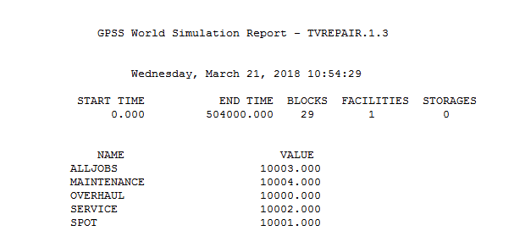

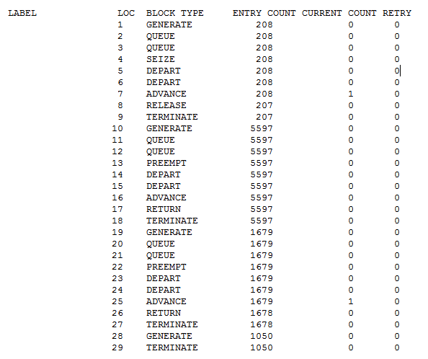

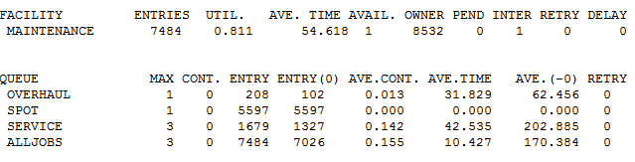

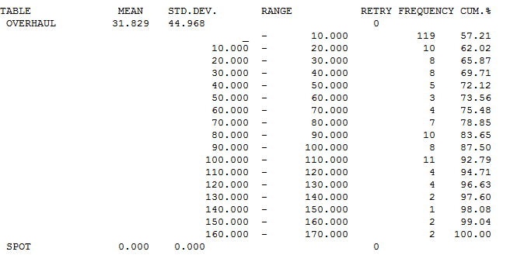

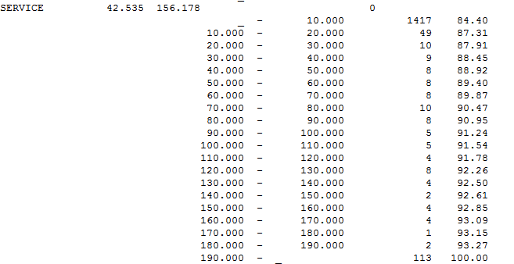

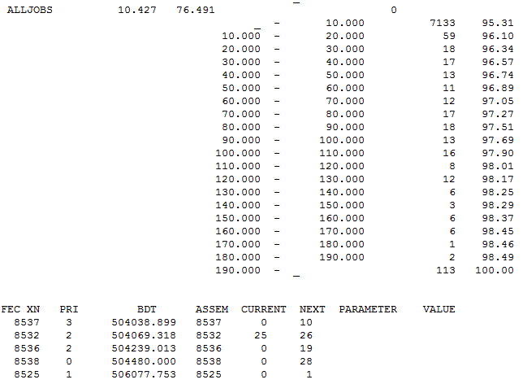

**Calculation:**

**Utilization of repairman= 0.783 i.e 78%**

**Delay in service to customer= Average waiting time= 10.47 mins**